Digital Egypt Pioneers Initiative رواد مصر الرقمية
Round 4 الدورة الرابعة
2025 - 2026 2025 - 2026

Track: AI & Data Science - Microsoft Machine Learning Engineer
Group Code: ONL4_AIS2_S7
Instructor: Eman Elgalad
Company Name: Skills Dynamix



Project Name

"AI-Powered Predictive Maintenance for Industrial Equipment"
No. | Name
1 | Moaz Osama Esamil Hataba (TL)
2 | Abrar Ashraf Shaban Ahmad
3 | Marwan Muhammad Darwish Ammar
4 | Yussef Ahmad Muhammad Elshamy
5 | Salma Muhammad Nageh Abdul-Hamid
6 | Nour-Eldin Kamel Muhammad Hasanein

Task |  | Page No. | Evaluation
Overview |  | 5
Problem Statement |  | 6
Objectives |  | 7
Scope |  | 8
Dataset Description |  | 9
Expected Outcomes |  | 10
Methodology |  | 11
TimeLine |  | 12
Gantt Chart |  | 13
Milestones |  | 14
Deliverables |  | 14
Resource Allocation |  | 15
Task Assignment & Roles |  | 16
Risk Assessment & Mitigation Plan |  | 17
Key Performance Indicators (KPIs) |  | 18

Planning
&
Management
Project Proposal:
- Overview
  - Predictive maintenance is an advanced maintenance strategy that uses data analysis, machine learning, and artificial intelligence techniques to predict equipment failures before they occur. Unlike reactive maintenance, which only addresses failures after they happen, and preventive maintenance, which depends on predefined maintenance schedules, predictive maintenance enables organizations to make proactive decisions based on the actual health condition of equipment.
  - This project aims to develop an Explainable Artificial Intelligence (XAI)-based Predictive Maintenance System capable of estimating the Remaining Useful Life (RUL) of industrial equipment using historical sensor measurements and operational conditions.
  - The system utilizes NASA’s Commercial Modular Aero-Propulsion System Simulation (CMAPSS) dataset, which contains simulated aircraft engine degradation data collected from multiple sensors under different operating conditions.
  - The proposed solution integrates:
    - Machine Learning models for accurate RUL prediction.
    - Explainable AI techniques using SHAP to interpret model decisions.
    - A RAG-based AI maintenance assistant to provide knowledge-based support.
    - An interactive Streamlit dashboard for monitoring, visualization, and prediction.
    - Backend services for model inference and system integration.
  - The project provides a complete AI-driven maintenance platform that improves equipment reliability, reduces downtime, optimizes maintenance operations, and increases trust in AI predictions through transparency and explainability.

- Problem Statement
  - Unexpected equipment failures represent a major challenge in industrial environments, causing production interruptions, financial losses, increased maintenance expenses, reduced equipment lifetime, and potential safety risks.
  - Traditional maintenance strategies have several limitations:
    - Reactive Maintenance: Equipment is repaired only after failure occurs, resulting in unexpected downtime and high repair costs.
    - Preventive Maintenance: Maintenance is performed according to fixed schedules, which may lead to unnecessary servicing or failure before the scheduled maintenance time.
  - These approaches lack the ability to continuously evaluate equipment health and predict future failures based on real operational conditions.
  - Therefore, there is a need for an intelligent predictive maintenance solution that can analyze sensor data, estimate equipment degradation, predict Remaining Useful Life (RUL), and support maintenance teams in making accurate and timely decisions.

- Objectives
  - Main Objectives
    - The main objective of this project is to develop an Explainable AI-driven Predictive Maintenance System that can:
      - Predict equipment failures before they occur.
      - Estimate Remaining Useful Life (RUL) accurately.
      - Reduce unexpected equipment downtime and maintenance costs.
      - Improve maintenance planning and operational efficiency.
      - Provide transparent AI predictions using Explainable AI techniques.
      - Offer an interactive and user-friendly monitoring dashboard.
  - Technical Objectives
    - Dataset Understanding
      - Analyze the structure and characteristics of the NASA CMAPSS dataset.
      - Understand sensor measurements and operational conditions.
      - Study equipment degradation behavior over time.
    - Data Analysis
      - Perform Exploratory Data Analysis (EDA).
      - Identify patterns, trends, and anomalies in sensor readings.
      - Analyze sensor importance and relationships.
    - Feature Engineering
      - Generate RUL labels from engine lifecycle data.
      - Extract statistical and time-series features.
      - Select the most relevant features for prediction.
    - Machine Learning Development
      - Develop regression models for RUL estimation.
      - Compare different models using RMSE, MAE, and R² metrics.
      - Optimize model performance through hyperparameter tuning.
    - Explainable AI
      - Integrate SHAP for model interpretation.
      - Identify important factors affecting predictions.
      - Improve transparency and trust in AI decisions.
    - System Deployment
      - Develop backend services for prediction.
      - Build an interactive Streamlit dashboard.
      - Integrate AI prediction, visualization, reporting, and maintenance assistance features.
- Scope
  - Included in Scope
    - NASA CMAPSS dataset collection and preparation.
    - Data cleaning and preprocessing.
    - Exploratory Data Analysis (EDA).
    - Feature engineering and feature selection.
    - Machine learning model development for RUL prediction.
    - Model optimization and performance evaluation.
    - Explainable AI implementation using SHAP.
    - Backend development for model inference.
    - Streamlit dashboard development.
    - RAG-based maintenance assistant integration.
    - Technical documentation and final presentation preparation.
  - Excluded from Scope
    - Real-time IoT sensor hardware integration.
    - Cloud deployment and enterprise production scaling.
    - Mobile application development.
    - Embedded system implementation.
    - Advanced deep learning research beyond project requirements.

- Dataset Description
  - Dataset Source
    - The project uses NASA’s Commercial Modular Aero-Propulsion System Simulation (CMAPSS) Turbofan Engine Degradation Dataset, a widely used benchmark dataset for predictive maintenance and Remaining Useful Life estimation.
    - The dataset contains multivariate time-series sensor measurements collected from simulated aircraft engines operating under different conditions and degradation scenarios.
  - Dataset Structure
    - The dataset consists of four subsets:
      - FD001 (Single operating condition with a single fault mode).
      - FD002 (Multiple operating conditions with a single fault mode).
      - FD003 (Single operating condition with multiple fault modes).
      - FD004 (Multiple operating conditions with multiple fault modes).
    - Training Data:
      - train_FD001.
      - train_FD002.
      - train_FD003.
      - train_FD004.
    - Testing Data:
      - test_FD001.
      - test_FD002.
      - test_FD003.
      - test_FD004.
    - Ground Truth Data
      - RUL_FD001.
      - RUL_FD002.
      - RUL_FD003.
      - RUL_FD004.
  - Dataset Features
    - Each record represents an engine condition at a specific operating cycle and contains:
      - Engine ID: Unique identifier for each engine.
      - Cycle: Represents operational time progression.
      - Operational Settings: Three parameters describing engine conditions.
      - Sensor Measurements: 21 sensor readings collected from engine components.
      - Remaining Useful Life (RUL): Target variable representing the number of cycles remaining before failure.
  - Dataset Characteristics
    - Type: Multivariate Time-Series Dataset.
    - Domain: Predictive Maintenance and Prognostics.
    - Application: Aircraft Engine RUL Prediction.
    - Operating Conditions: Single and multiple conditions.
    - Fault Modes: Different degradation scenarios.
- Expected Outcomes
  - Accurate RUL Prediction
    - Develop a reliable machine learning model capable of estimating equipment health and predicting future failures.
  - Explainable AI Framework
    - Provide transparent prediction explanations using SHAP, allowing users to understand the impact of different sensor features.
  - Intelligent Maintenance Support
    - Enable maintenance teams to make proactive decisions based on predicted degradation and failure risks.
  - Reduced Downtime and Costs
    - Minimize unexpected failures and optimize maintenance schedules.
  - Interactive AI Dashboard
    - Provide a Streamlit-based interface for:
      - Real-time RUL prediction.
      - Equipment monitoring.
      - Data visualization.
      - Maintenance management.
  - AI Maintenance Assistant
    - Provide a RAG-based assistant capable of answering maintenance questions using a domain-specific knowledge base.
  - Professional Documentation
    - Deliver complete technical documentation and final project presentation.
Project Plan:
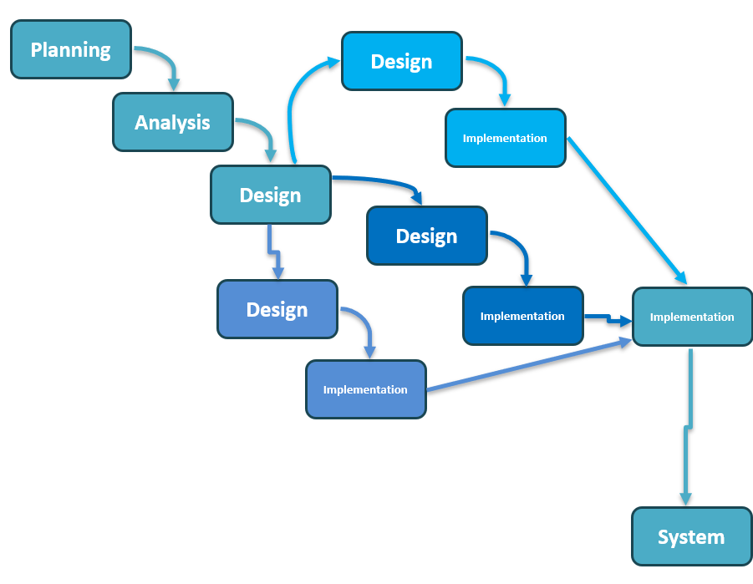
- Methodology (Parallel Development)

- TimeLine
Phase | Duration | Responsible Members
Requirements & Architecture | Week 1–2 | Moaz Osama
Data Preparation & Analysis | Week 2–3 | Abrar Ashraf
Model Development | Week 3–5 | Abrar Ashraf & Nour-Eldin Kamel
Application Development | Week 5–8 | Marwan Muhammad & Salma Muhammad
Database & Reporting | Week 6–8 | Yussef Ahmad
Testing & Integration | Week 8–9 | Moaz Osama & Salma Muhammad
Documentation & Presentation | Week 9–10 | Moaz Osama, Abrar Ashraf, & Salma Muhammad

- Gantt Chart
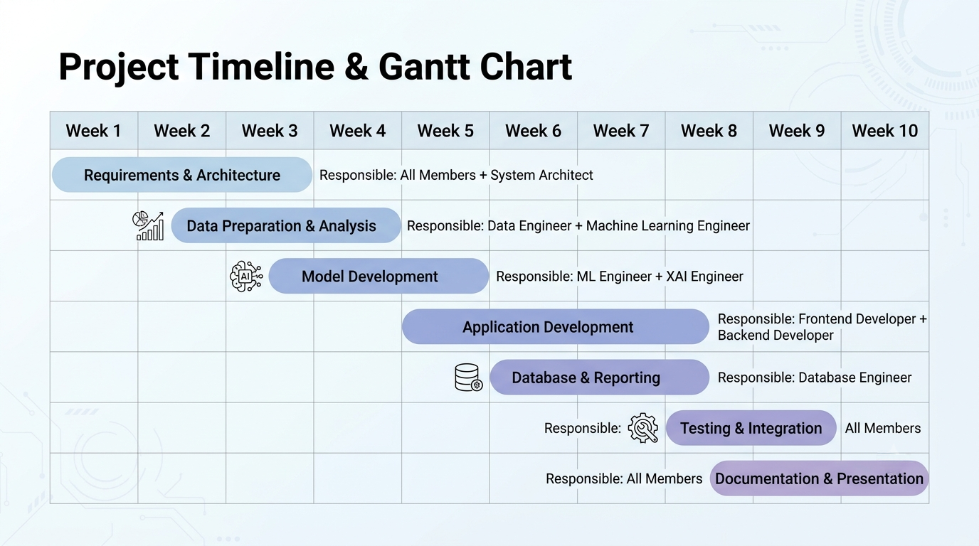
- Milestones
No. | Milestone | Description
1 | Dataset  Preparation | Collect, clean, validate, and preprocess NASA CMAPSS data
2 | Exploratory Data Analysis (EDA) | Analyze sensor behavior and degradation patterns
3 | Feature  Engineering | Generate RUL labels and extract useful features
4 | Model  Development | Train and evaluate ML models
5 | Model  Optimization | Tune parameters and improve performance
6 | Application Development | Develop Streamlit dashboard and integrate system components
7 | Final Documentation and Presentation | Prepare reports and final presentation
- Deliverables
  - Prepared and validated dataset.
  - Completed exploratory data analysis.
  - Engineered features for ML modeling.
  - Trained machine learning model.
  - Optimized and evaluated prediction model.
  - Explainable AI module using SHAP.
  - RAG maintenance assistant.
  - Completed Streamlit application.
  - Technical documentation.
  - Final presentation.

- Resource Allocation
Resource Category | Allocation | Description
Human Resources | Project  Team | Responsible for development, testing, integration, and documentation
Dataset | NASA CMAPSS Dataset | Provides engine sensor data for RUL prediction
Programming Tools | Python Ecosystem | Pandas, NumPy, Scikit-learn, XGBoost, SHAP, FAISS
Development Environment | Jupyter Notebook / VS Code | Used for coding, analysis, and model training
Backend Services | FastAPI | Provides prediction APIs and system integration
Frontend | Streamlit | Interactive dashboard and visualization
AI Services | Groq LLM + RAG Pipeline | Knowledge-based maintenance assistant
Experiment Tracking | MLflow | Model tracking and lifecycle management
Computing Resources | Personal Computer | CPU-based development and training
Documentation Tools | Microsoft Word / PowerPoint | Reports and final presentation preparation

Task Assignment & Roles:
Team Member | Role | Responsibilities
Moaz Osama | Project Manager & System Architect | Architecture design, task coordination, integration, documentation, presentation
Abrar Ashraf | Machine Learning Engineer | Data preprocessing, feature engineering, model development, training, tuning, evaluation, XGBoost implementation
Nour-Eldin Kamel | Data Engineer & XAI Engineer | SHAP explanations
Salma Muhammad | Backend & Authentication Engineer | Backend services, authentication, APIs, system logic
Marwan Muhammad | Frontend & RAG Engineer | Streamlit dashboard, UI development, RAG assistant integration
Yussef Ahmad | Database, Reporting & QA Engineer | Database design, reports, testing, quality assurance

Risk Assessment & Mitigation Plan:
Risk | Role | Responsibilities
Poor data quality or missing values | Reduced model accuracy | Perform data cleaning, preprocessing, and validation before training
Low prediction accuracy | Unreliable RUL estimation | Compare multiple ML models, tune hyperparameters, and evaluate using RMSE, MAE, and R²
Difficulty interpreting AI predictions | Reduced user trust | Integrate SHAP to provide transparent feature importance explanations
Integration issues between system components | Delays in development | Adopt a modular architecture and perform continuous integration and testing
RAG retrieval returns irrelevant information | Inaccurate maintenance recommendations | Optimize text chunking, embeddings, and FAISS similarity search; improve the knowledge base
Team schedule delays | Missed project milestones | Monitor progress through weekly meetings, task tracking, and milestone reviews
Technical or software compatibility issues | Development interruptions | Use version control (Git), virtual environments, and dependency management
Limited computing resources | Longer training and processing time | Optimize code, use efficient algorithms, and leverage pre-trained models where possible

Key Performance Indicators (KPIs):
KPI Category | Metric | Target / Measurement
Model Performance | RUL Prediction Accuracy | Evaluate model performance using RMSE, MAE, and R² metrics to ensure reliable Remaining Useful Life estimation
Prediction Response Time | Inference Latency | Generate RUL predictions within less than 1 second after receiving valid input data
System Availability | Application Uptime | Maintain system availability above 95% during testing and demonstration phases
Dashboard Performance | Loading Time | Ensure Streamlit dashboard loads within 3 seconds under normal operating conditions
Explainability Quality | SHAP Interpretation | Provide clear feature importance explanations for model predictions
RAG Assistant Performance | Response Relevance | Provide clear feature importance explanations for model predictions
System Integration | Component Reliability | Successfully integrate ML model, XAI module, RAG assistant, backend services, and dashboard without failures
User Experience | Interface Usability | Provide an intuitive dashboard allowing users to easily monitor equipment health and access predictions
Documentation Quality | Project Completeness | Deliver complete technical documentation, reports, and final presentation materials
Team Progress | Milestone Completion | Complete all planned milestones according to the project timeline

